**ASSIGNMENT : 01**

**PERFORMED BY : ALI ASAD**

**SAP ID : 65320**

**PERFORMED FROM : SIR SHAHZAD AHMAD**

**Q.01:** Considering the prevalent security threats, Ministry of Education has instructed each institute to take foolproof security measures. Riphah International University, along with other actions, has issued all its students special security passes that will have to be shown at the main gate before anyone would be allowed to enter. The format of the security pass is as follows: /\/\/\/\/\/\/\/\/\/\/\/\/\/\/\/\/\/\/\/\/\/\/\/\/\

RIPHAH INTERNATIONAL UNIVERISTY – I/14 CAMPUS

--Student Security Pass—

-----------------------------------------------------------------------------------------------

|Name of the Student|

|Father’s Name|

|CMS of the Student|

|Batch of the Students|

\*\*\*\*\*\*\*\*\*\*\*\*\*\*\*\*\*/*/*/*/*/*/*/*/*/*/*/*/*/*/*/*/*/

**ANSWER:**

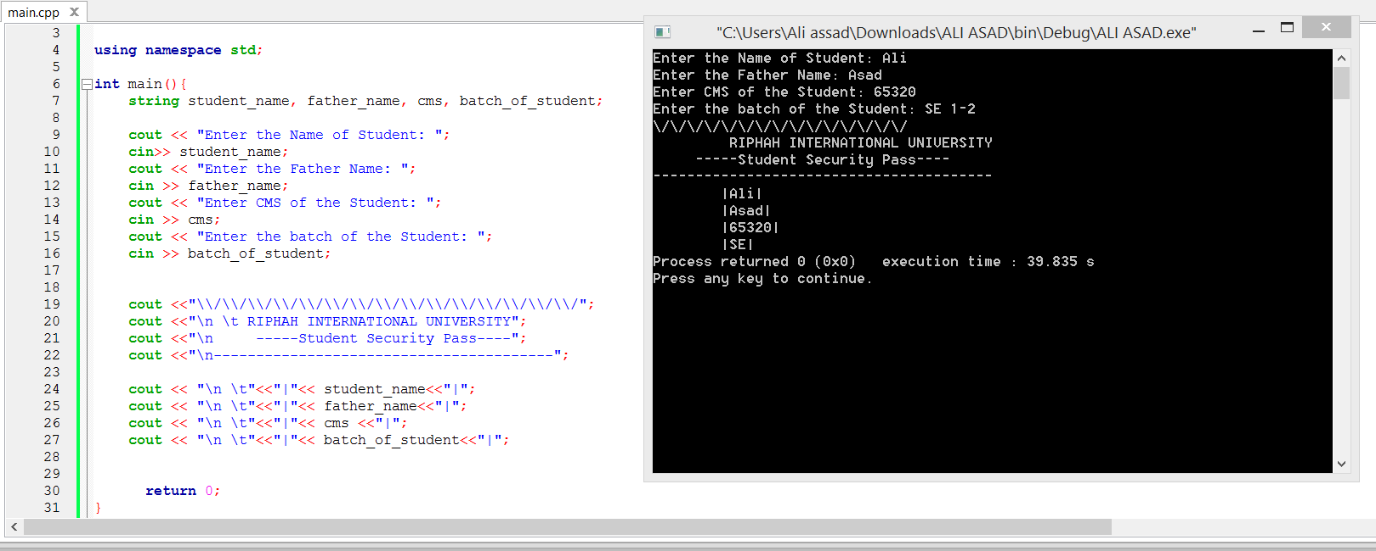

**Q2**: **Write a program that produces the following (or similar) output**

\\\\\\\\\\\///////////

\ o o /

\ x /

\ -- /

\________/

||||||||

______/_||_\______

|||||||||||||||||||

HELLO WORLD!!

**ANSWER:**

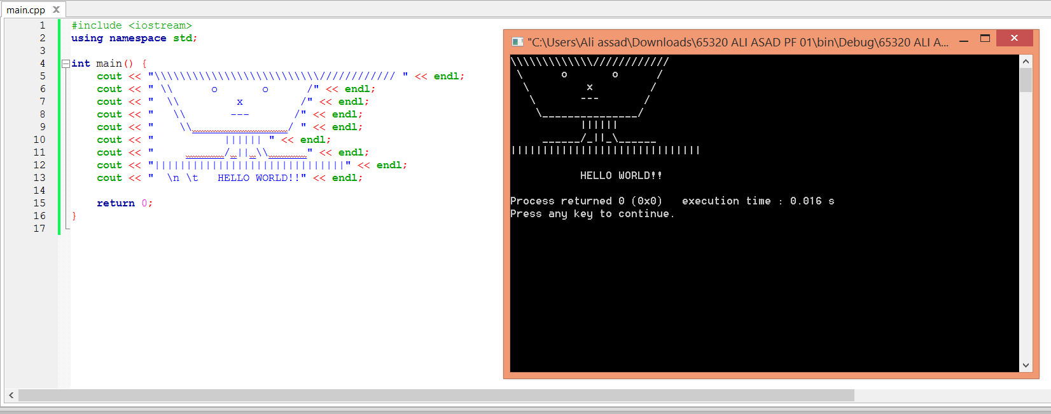

**Q 3 : Write a program that prints the following table**

**|Date: January 1, 1999. |**

**| Temperature record – Major Cities: (Celsius Scale) |**

**City Min Max**

**Islamabad 2 8**

**Lahore 5 11**

**Karachi 7 12**

**Multan 4 9**

**Murree -3 1**

**ANSWER:**

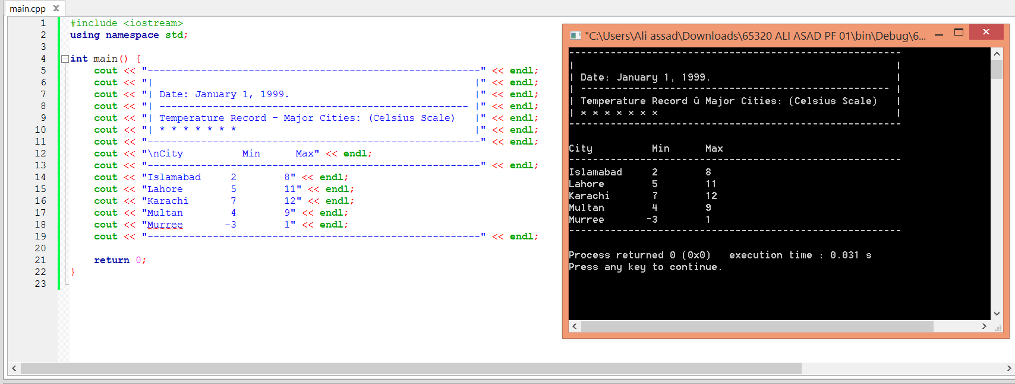

**Q4:Write a Program that declares 3 float variables named num1, num2 and num3. Now prompt the user to enter values for these variables. Print the following for each of these numbers. Number Square Cube Half For example if the user enters 3, 8, and 11 then your output will be:**

Number Square Cube Half

3 9 27 1.5

8 64 512 4

11 121 1331 5.5

**ANSWER:**

